# Grocery Shopping Vision

Started 22/03/2020

Ignas Rocas

## Introduction

We wish to develop a Grocery Shopping mobile application that allows user to create a list of grocery items that they regularly buy with time they take to consume it. The app will notify the user automatically if they are going to run out of any particular product in the list. App will allow user to select date when they are going to be shopping next, so app will pre-add items to a list. The main purpose of the app is to save time, making sure user has the items they need without checking if they have them.

## Business Case Summary

* Customer Segments

Customers will be anyone wanting to save time shopping.

* Value Proposition

Time is most important factor, since nobody likes shopping.

Try to catch items about to run out before user does, to see the value in the app.

* Channels
* Customer Relationships
* Revenue Stream
* Could display where to shop and get revenue from them.
* Subscription fee is a possibility.
* Free version with limited number of items can be set to a list and paid version.
* Key Resources

Learn Android Development etc.

* Key Activities
* Key Partnerships
* Cost Structure:

marketing costs

maintaining costs

## ~~Stakeholders Description and Goals~~

## Software Overview

The app has to be responsive and accurate with time of notifications. The GUI should be clear and well designed. The user should be able to add a new item to a list while saving it to the cloud in seconds, while automation of times should be accurate.

The system will be made in two parts (see Figure 1):

* **Mobile Client** : Grocery Shopping app will run on Android smartphones while allowing users to record their groceries with a time it can run out. The mobile clients will communicate to the Grocery Shopping cloud application to store the data entered by the user.
* **Cloud Application**: the cloud application will store the information received by the mobile clients (e.g. products, run out times, shopping date). It will also send information to mobile clients on requests to notify users on the product run-out time or to simply add products to a shopping list on the specified shopping day.

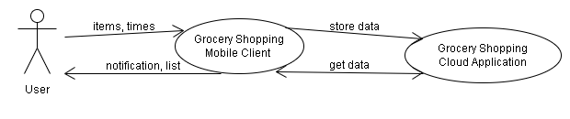

1.Figure, Context Diagram

## Summary of Software Features

screens shots…todo

## Main Risks Summary

The main risks identified so far are:

* Business Risks:
  + Competitors: there are many such systems already available[…..todo]
  + Value Proposition: this has not been validated yet.
  + Costs and revenues have not been estimated.
* Technological Risks:
  + The cloud platform has not yet been chosen.
  + Supporting many mobile clients is expensive.
  + Running job scheduler can be difficult.
* Project Risks:
  + There is a worldwide lack of software developers.
  + Cloud and Mobile platforms are fast changing immature technologies.

## References